# Michael Johnson

# CS 54D Summer

# Lab 05 vSphere and vCenter

In vSphere create a new vm

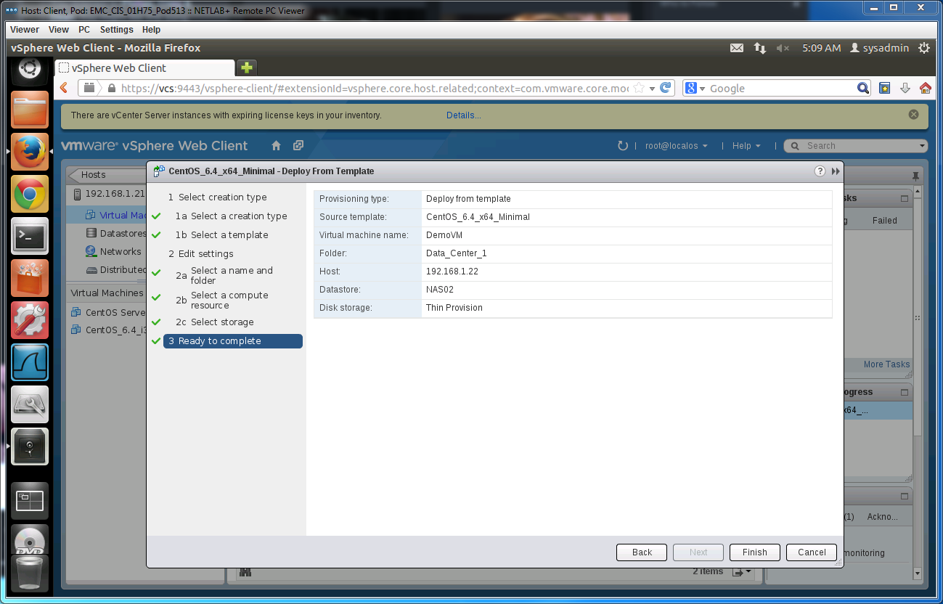

Confirmed VM is powered on.

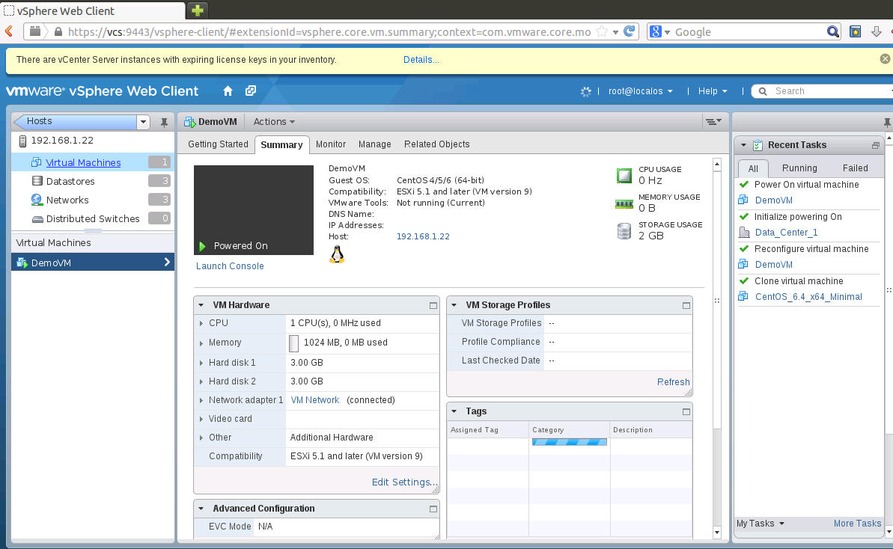

Performance check

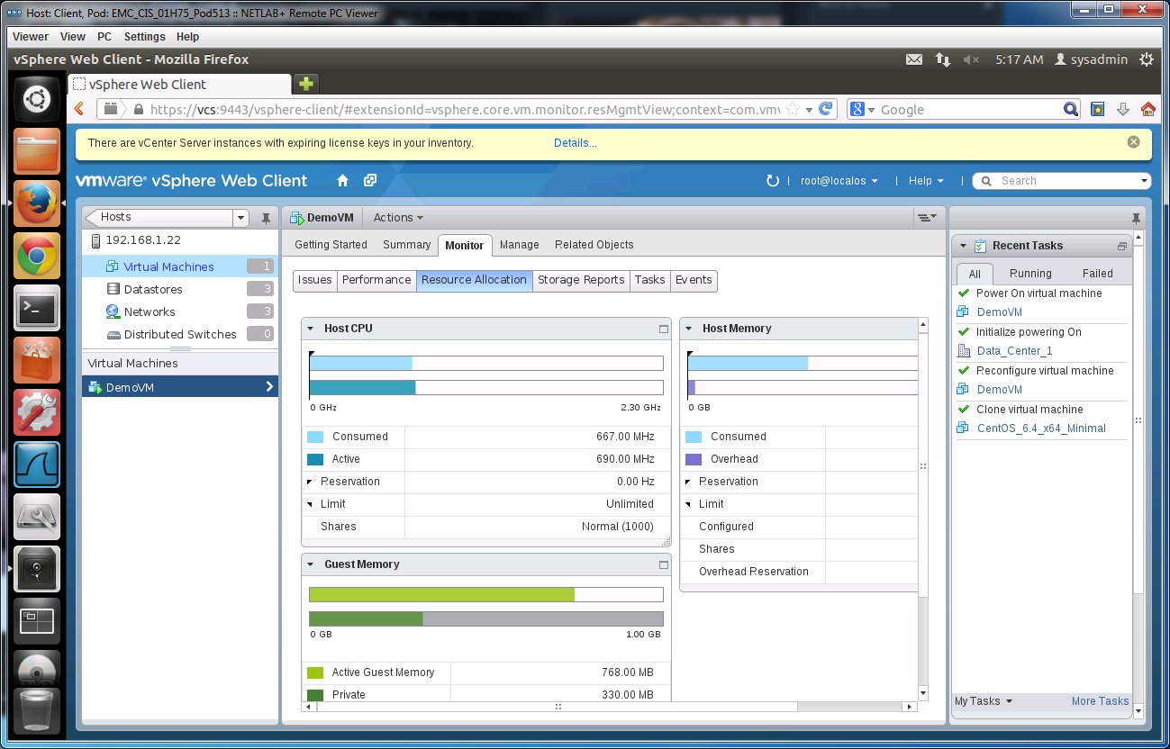

Open the new Vm Console  
  
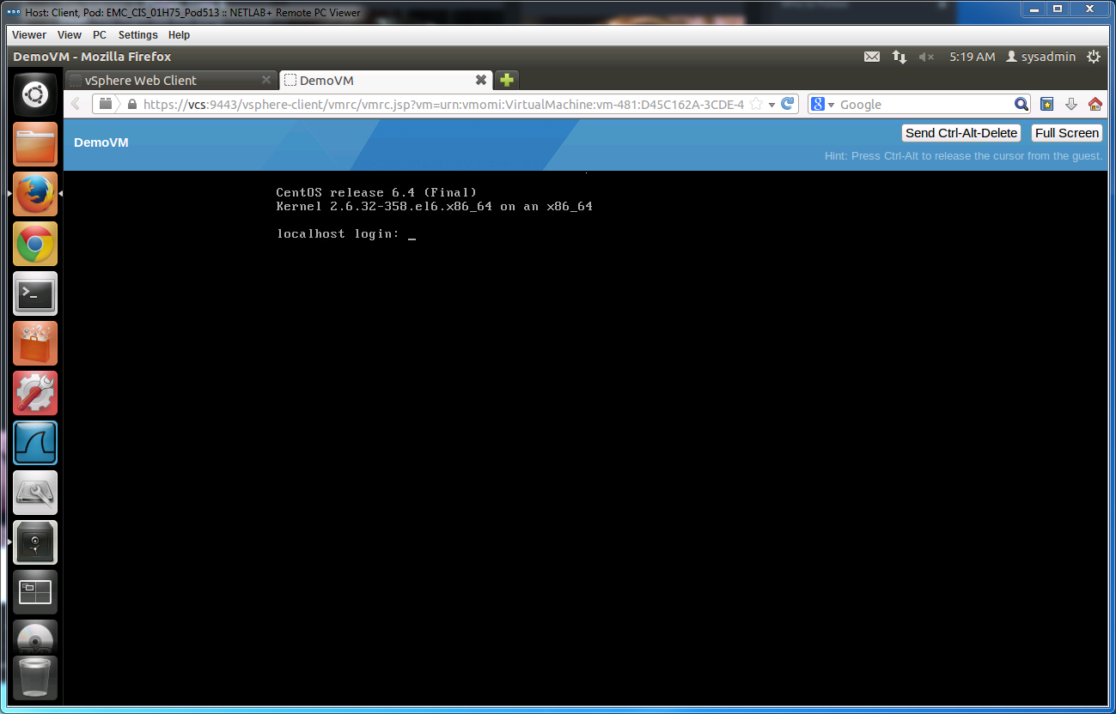

Now we took time to learn to Navigate the Menu and understand where things are in vCenter

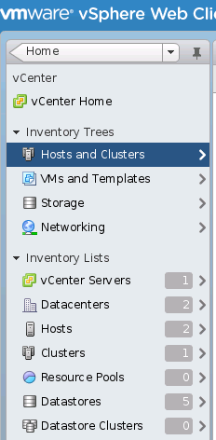

Turn on DRS so we can make a resource pool

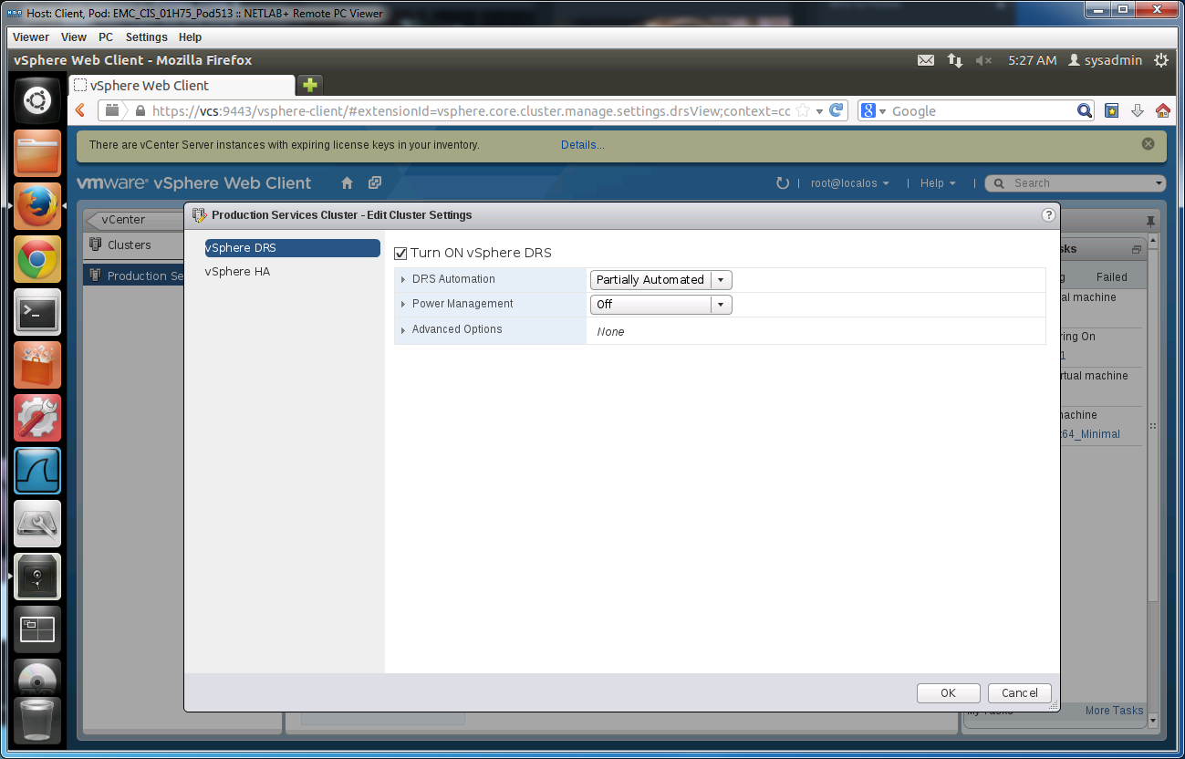

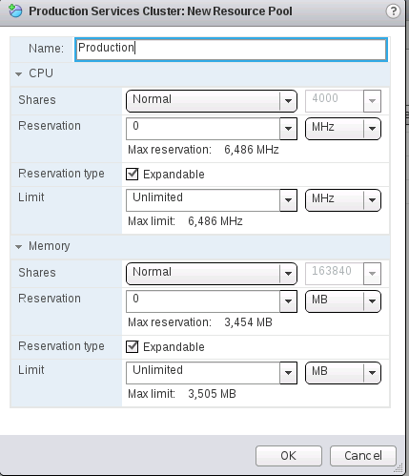

Now we add a new resource Pool

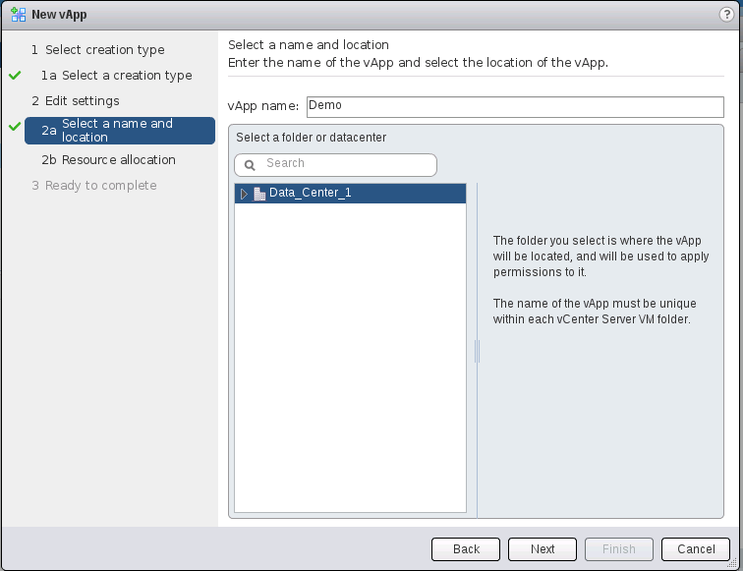

Now we make a new vApp

Move the DemoVM we mad earlier to the Demo vApp  
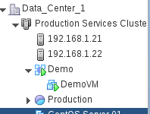

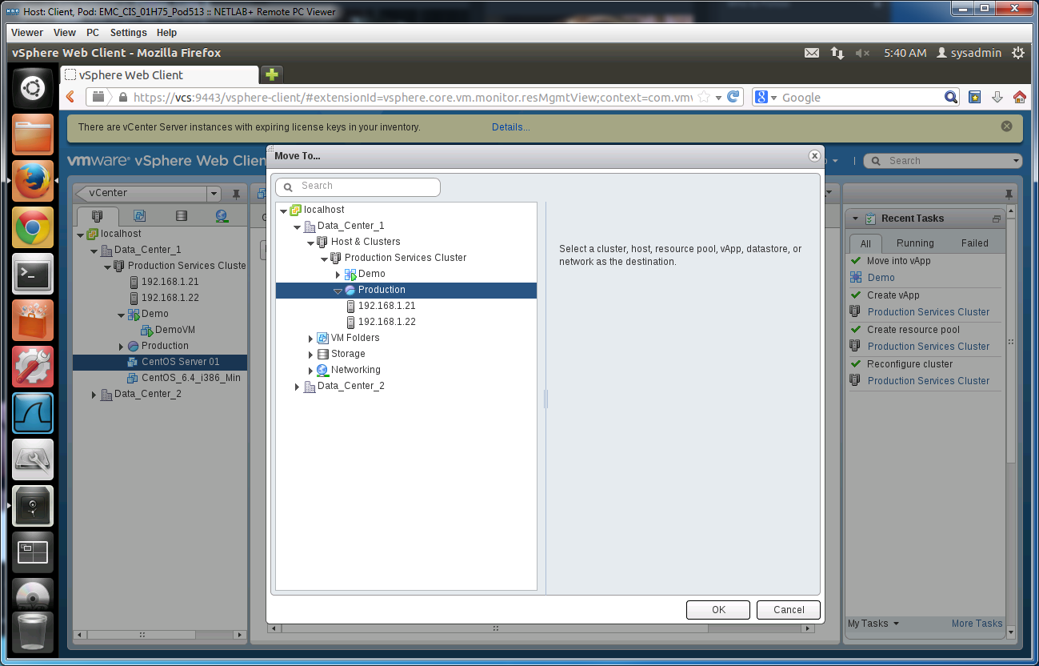

Move CentOS Server to Production

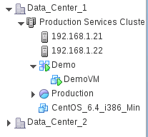

And we are done!